**Multi Module Maven Project:**

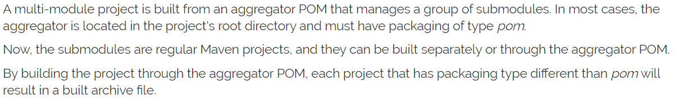

**Benefits:**

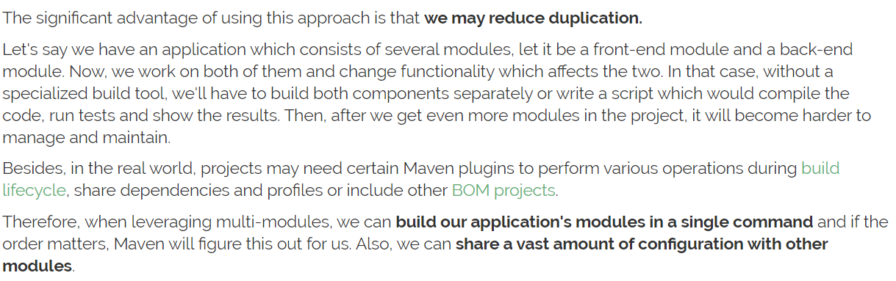

**Parent POM:**

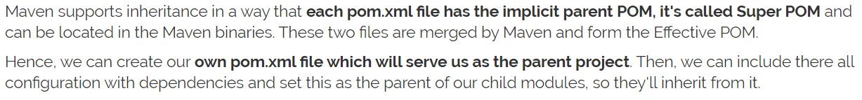



**Submodules:**



**Creating parent POM:**

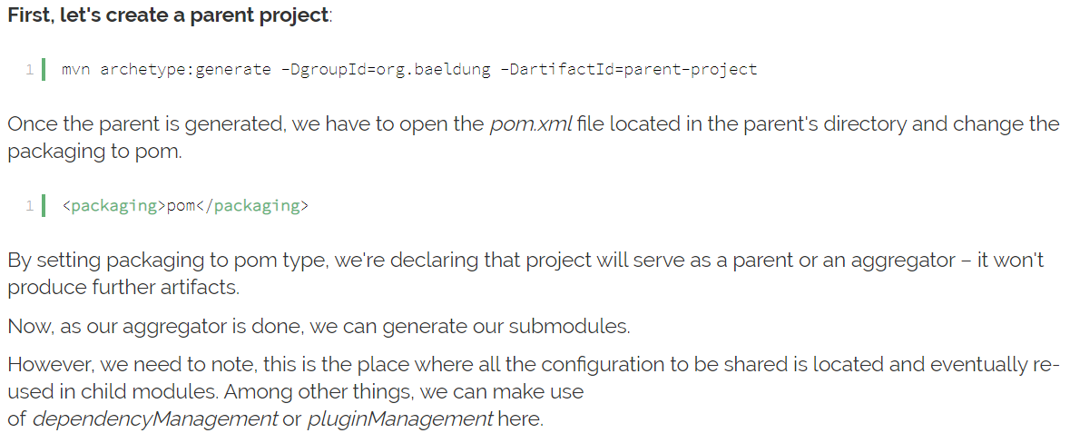

**Creating modules:**

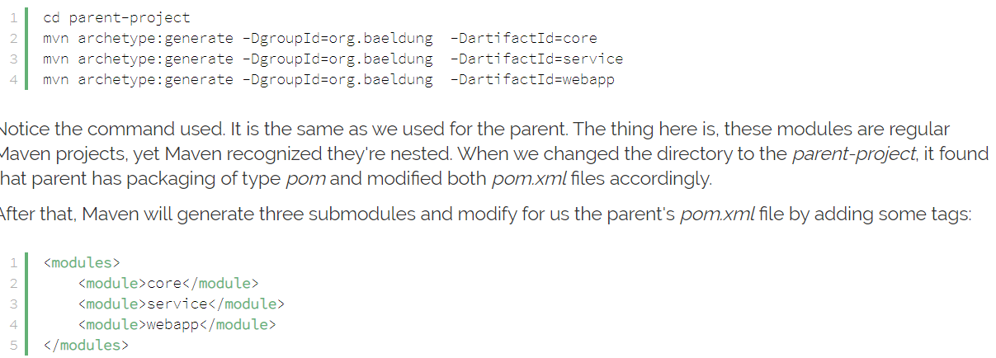

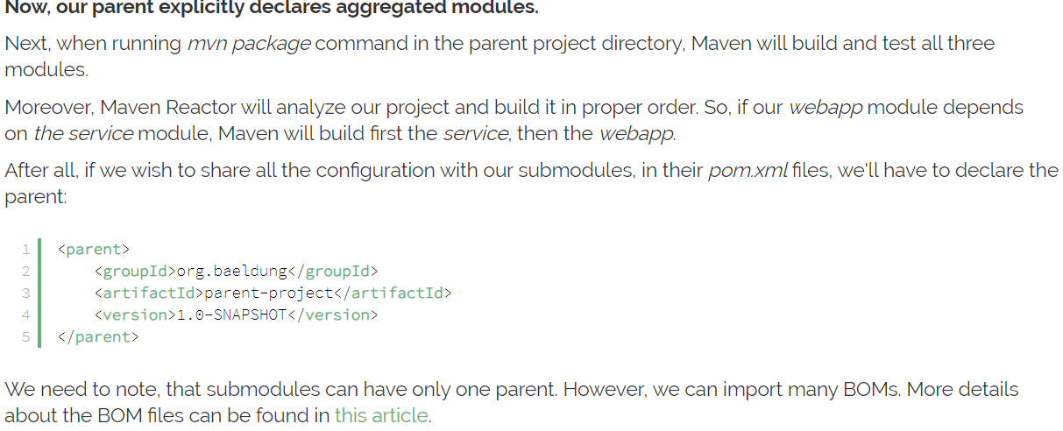

**Building the project:**

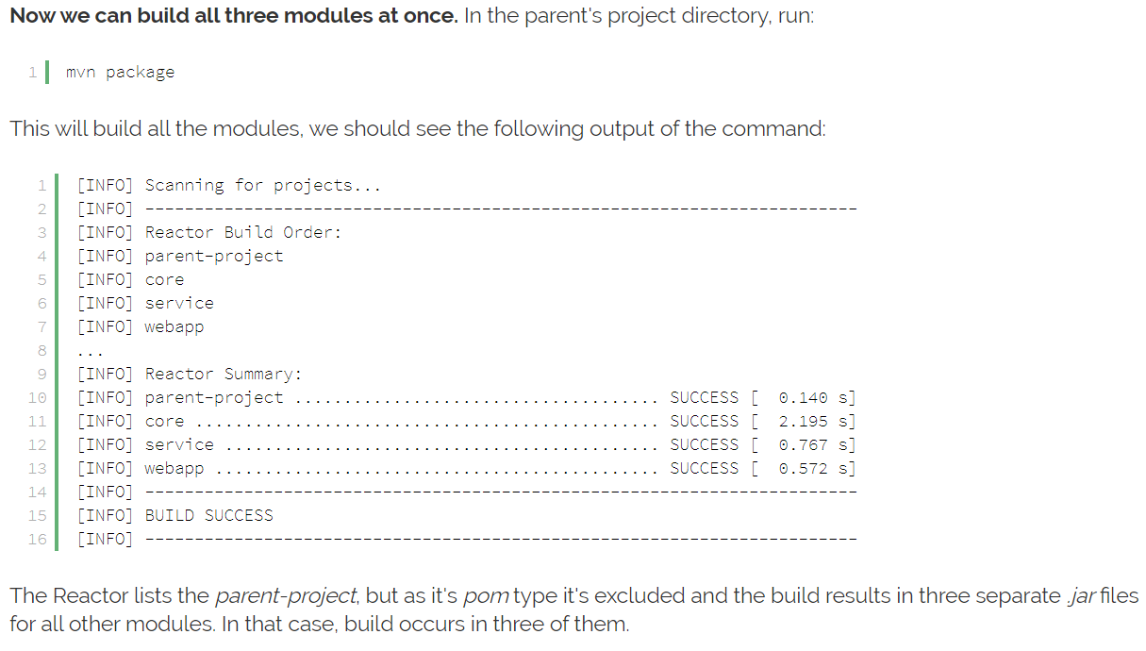

**Below are the example pom.xml files:**





mvn clean install -Dmaven.test.skip=true -Pe2s -Pe2s_build_e2s_app

**Convert normal project to multimodule:**

* If the code is already present in folders, we can simply create a pom.xml with basic instructions in parent directory and add “<module>” instruction in pom.xml
* Or if we have code in separate repositories or directories, we can create a new parent project and cd to that project and clone all the submodule projects to that and change the origin of main directory to git repo and push

**More explanation:**

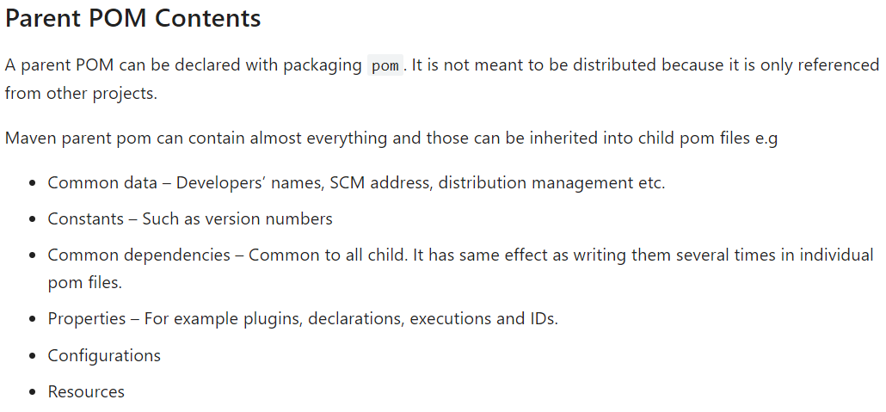

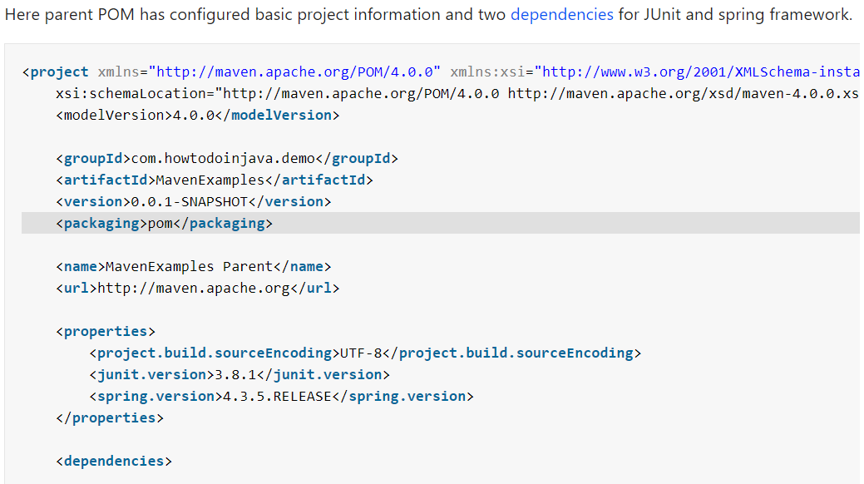

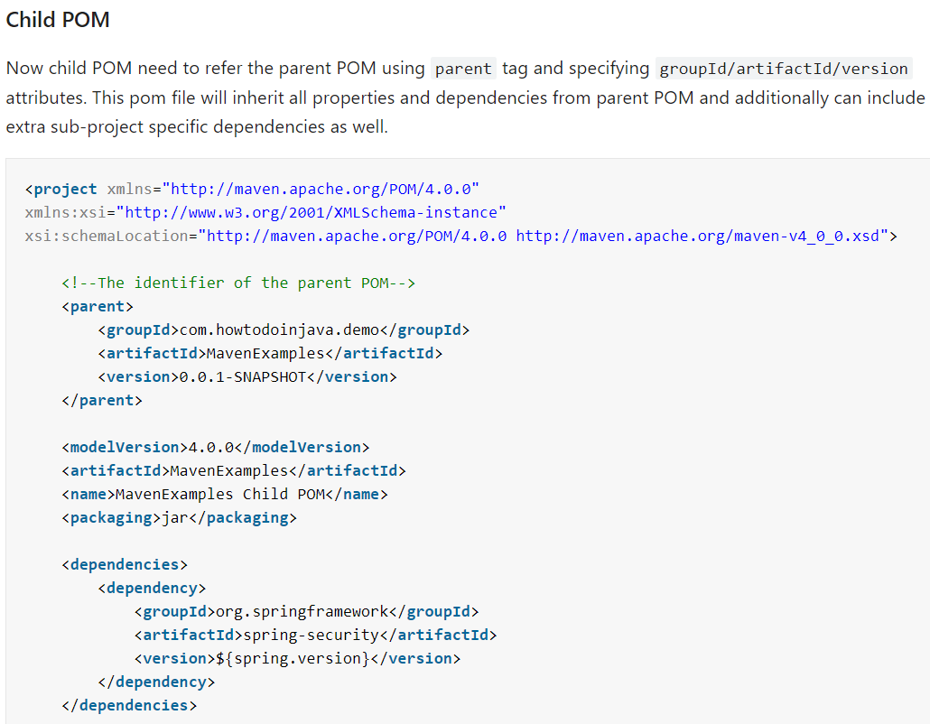

* As above, we need add “project” tag to the child pom.xml file. So that the child module can read all the configurations from parent pom
* If we want, we can also add extra configurations or dependencies to child pom.xml
* We may can add only common dependencies to the parent pom.xml

**Parent POM relative path:**

